Information Technology Engineering

Class: G9-M2

Name: Ly Uttakra

Assignment: Database Design and Implementation

SQL queries with explanations:

1. Retrieve all students who enrolled in a specific course.

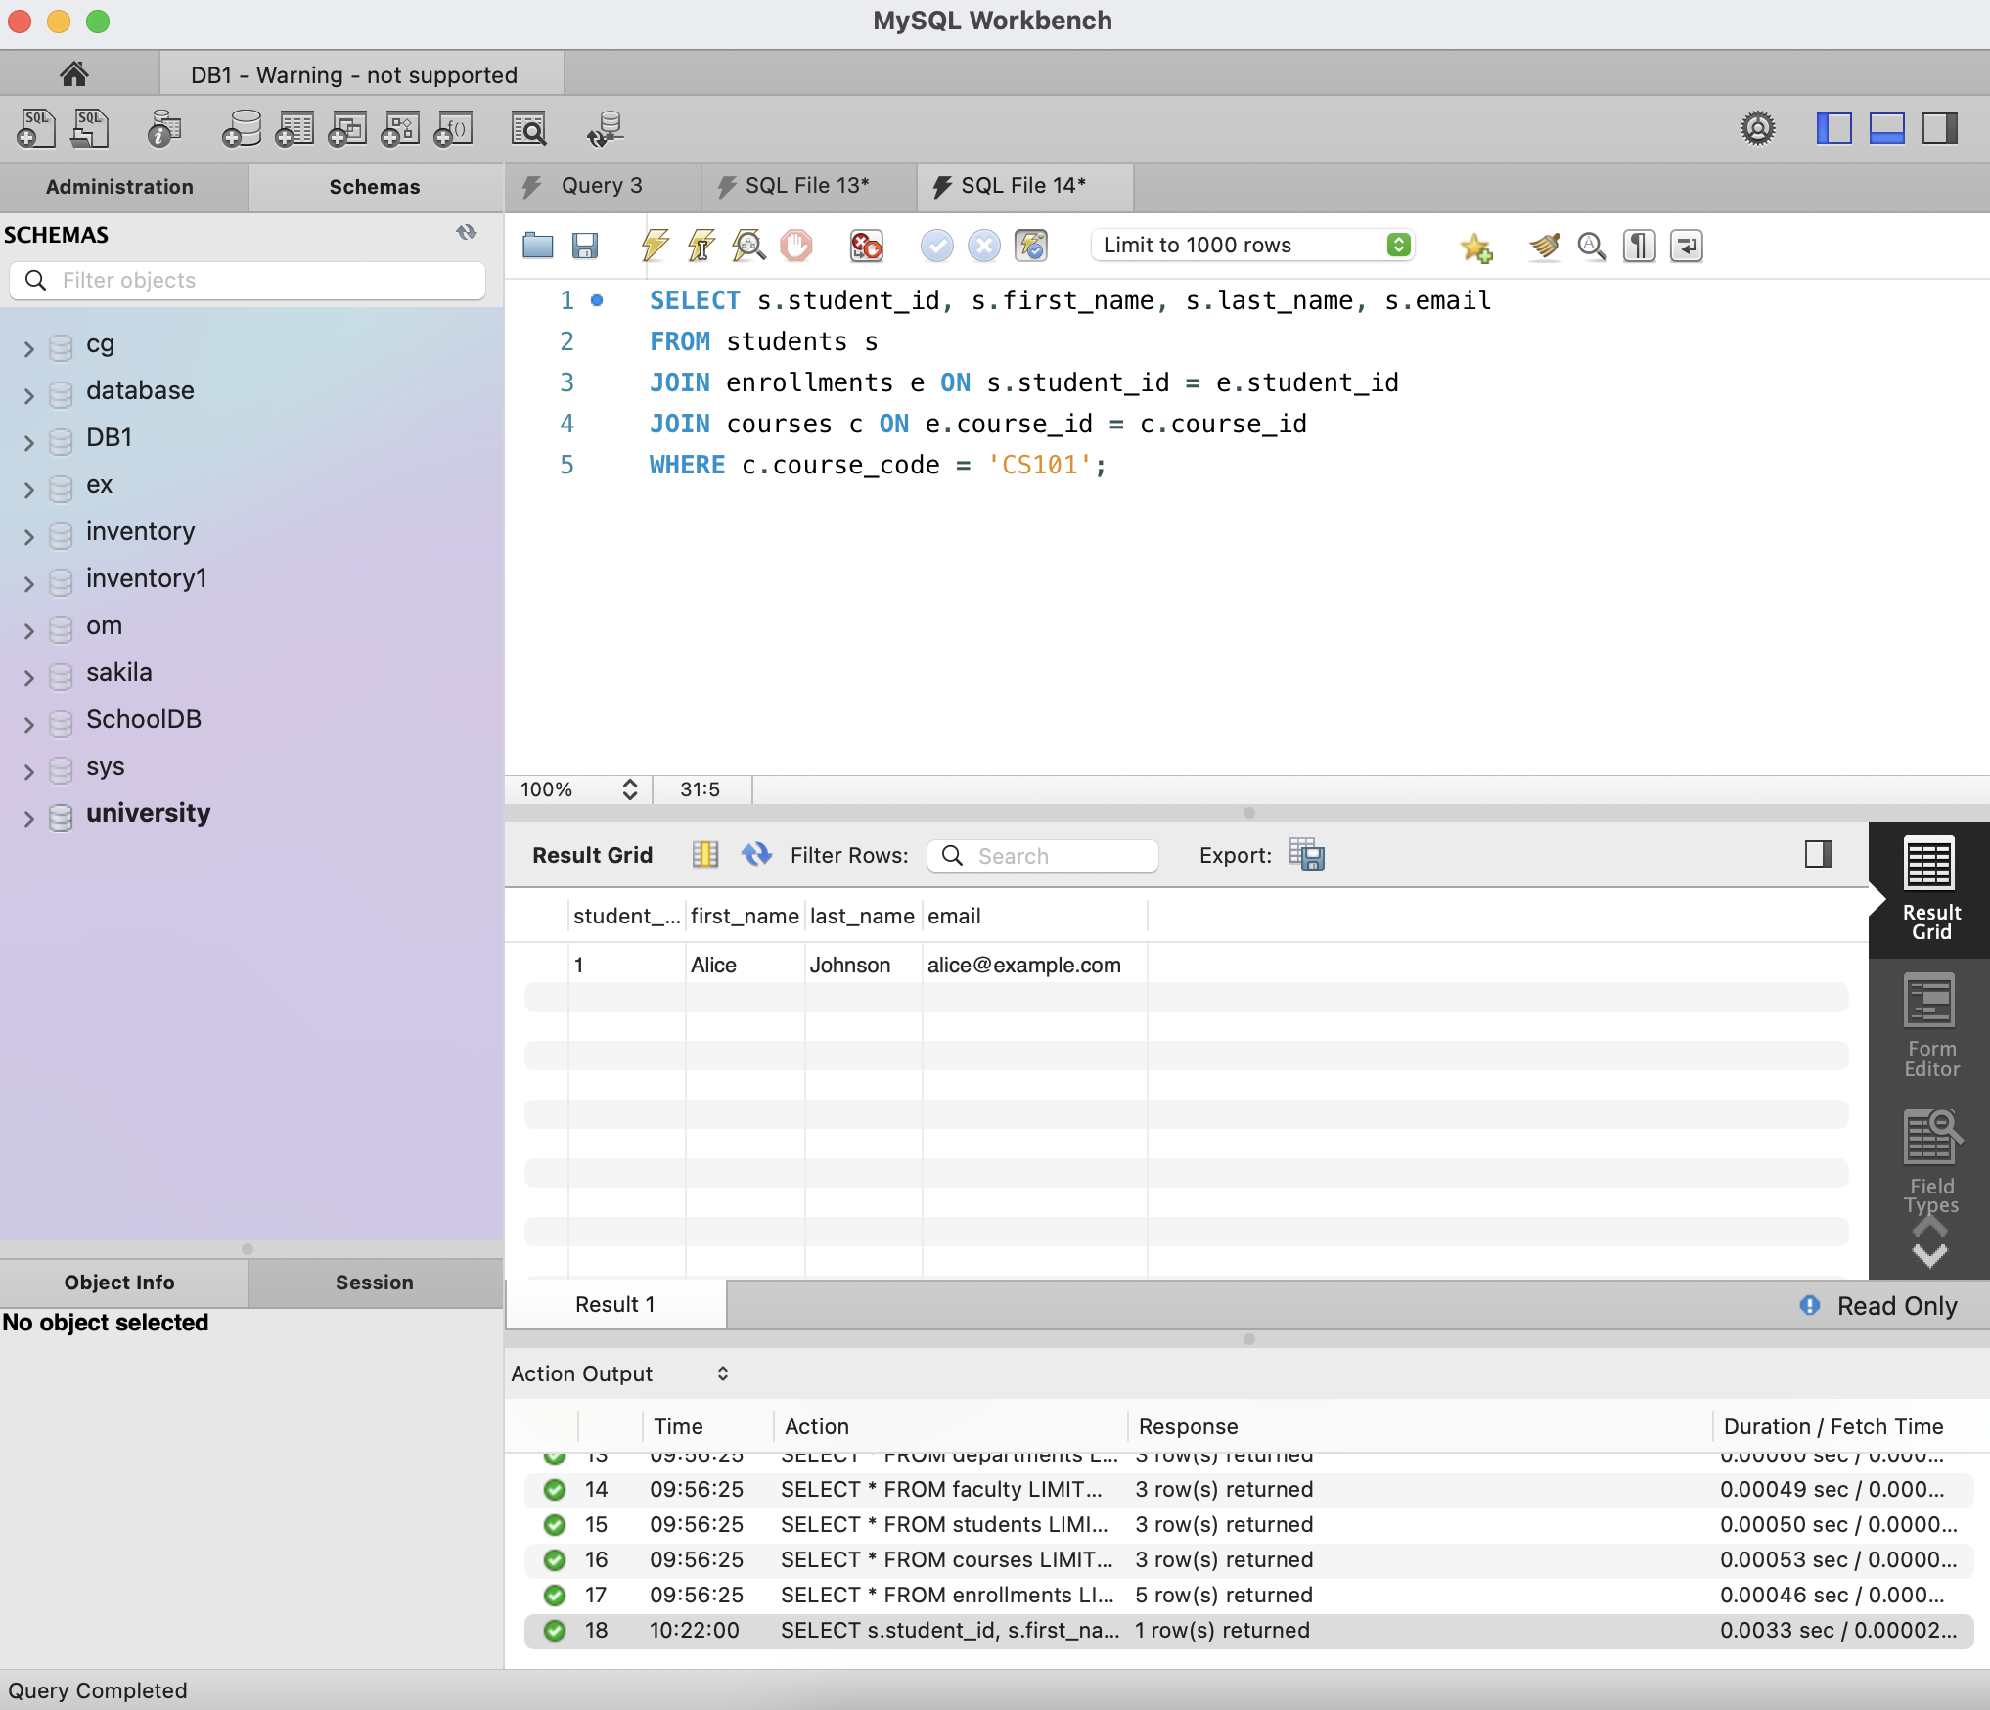

How it works:

• Merges the students, enrollments, and courses tables to identify students registered for a

specific course.

• Applies a filter on course_code (substituting 'CS101' with the desired course).

2. Find all faculty members in a particular department.

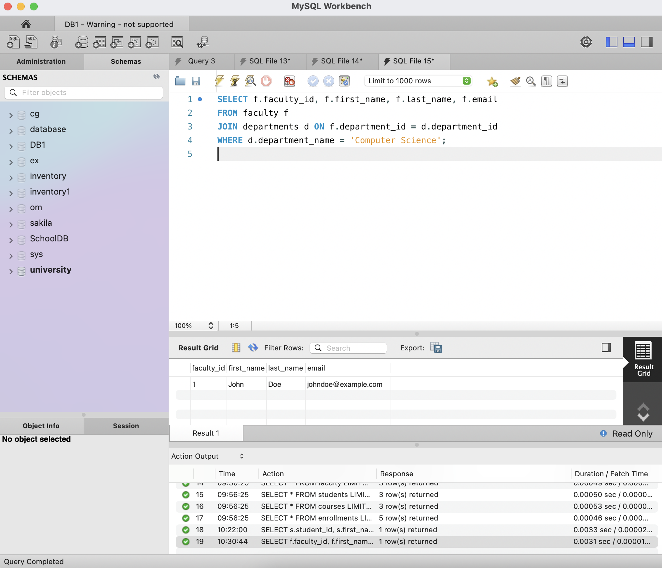

How it works:

• Combines the faculty and departments tables to associate faculty members with their respective

departments.

• Applies a filter on the department name (replace 'Computer Science' with the desired department).

3. List all courses a particular student is enrolled in.

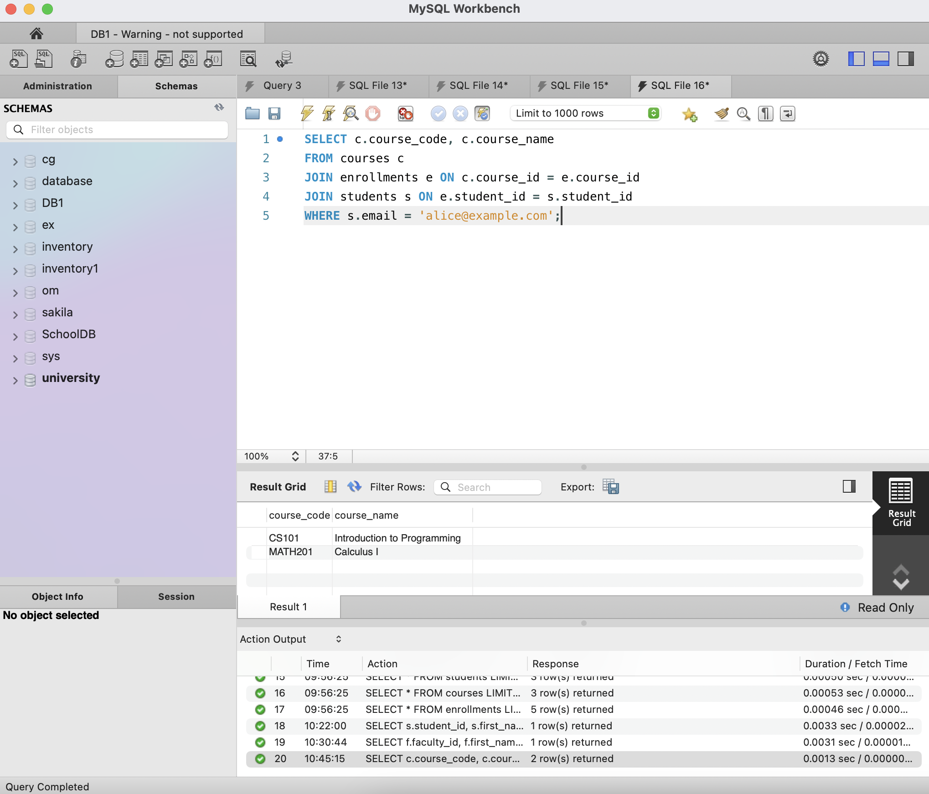

How it works:

• Joins the students, enrollments, and courses tables to retrieve courses linked to a specific student.

• Filters the results using the student's email (replace 'alice@example.com' with any student's email).

4. Retrieve students who have not enrolled in any course.

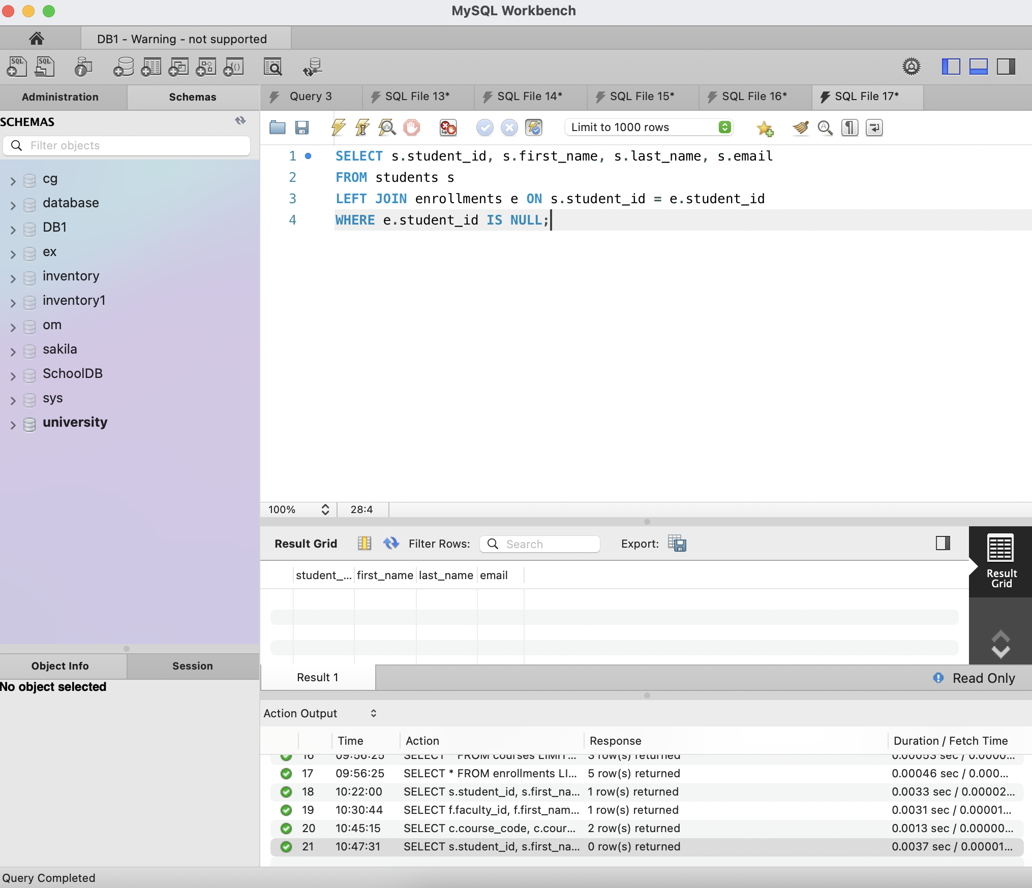

How it works:

• Performs a LEFT JOIN between students and enrollments, ensuring all students remain in the result.

• Excludes students who have at least one matching enrollment record.

• A NULL value in e.student_id indicates that the student has no enrollments.

5. Find the average grade of students in a specific course.

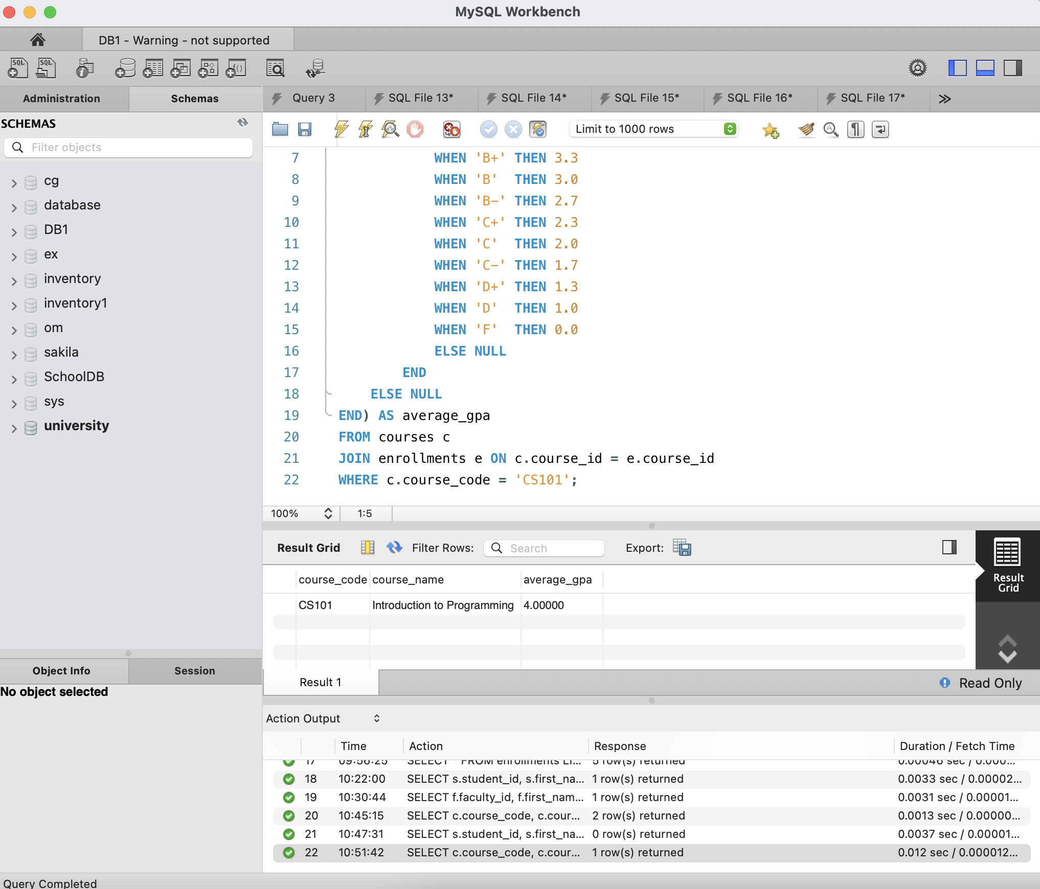

How it works:

• Joins the courses and enrollments tables to retrieve student grades for a specific course.

• Maps letter grades (A, B+, etc.) to their corresponding GPA values (e.g., A+ = 4.3, F = 0).

• Calculates the average GPA of students enrolled in the course.

Bonus:

I. Implement a trigger to update a student's GPA when a grade is updated.

a. Step 1 : Add a gpa Column to students Table By

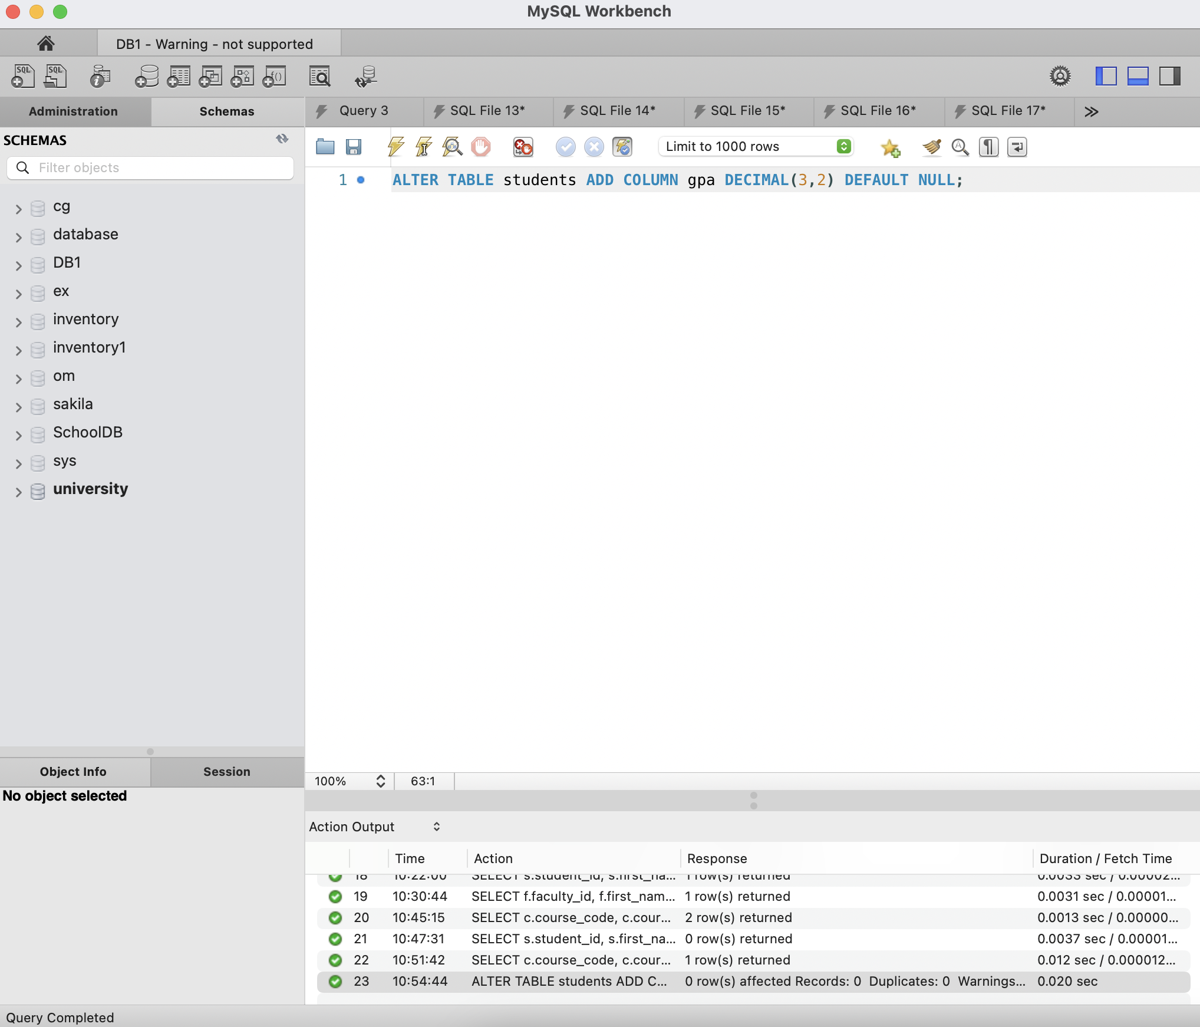

b. Step 2: Create the Trigger

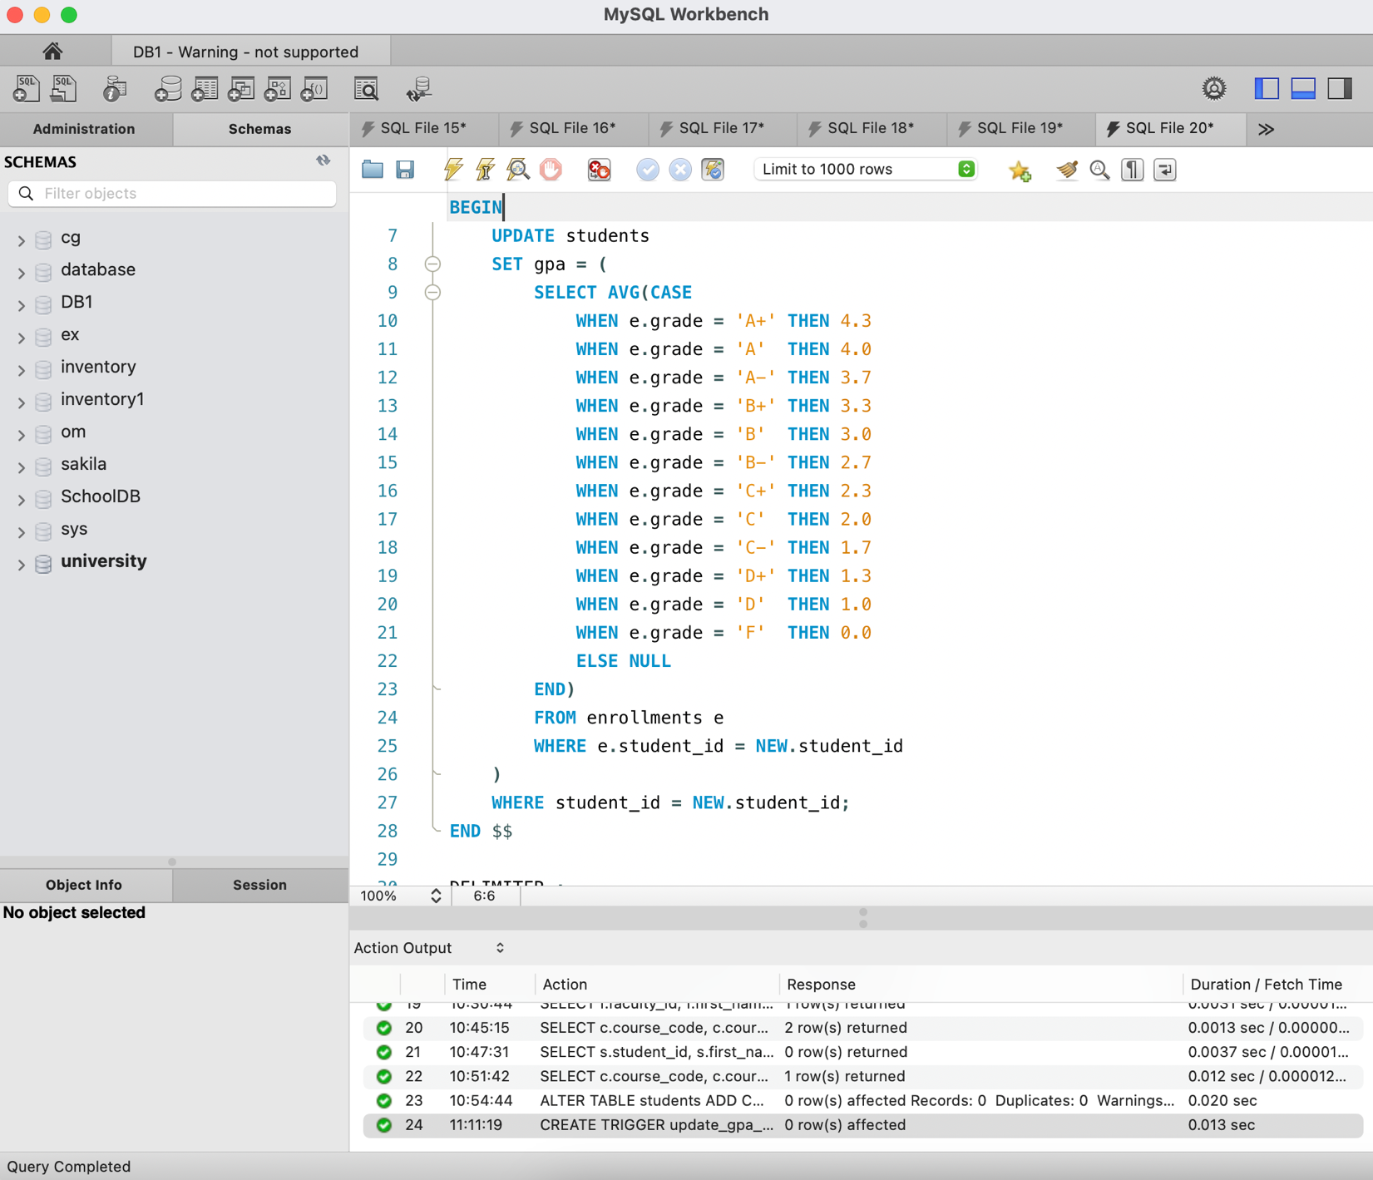

How it works:

• Transforms letter grades (A, B+, etc.) into GPA values on a 4.0 scale.

• Computes a student's average GPA from all their grades.

• Updates the gpa column in the students table with the calculated value.

II. Design a stored procedure to enroll a student in a course.

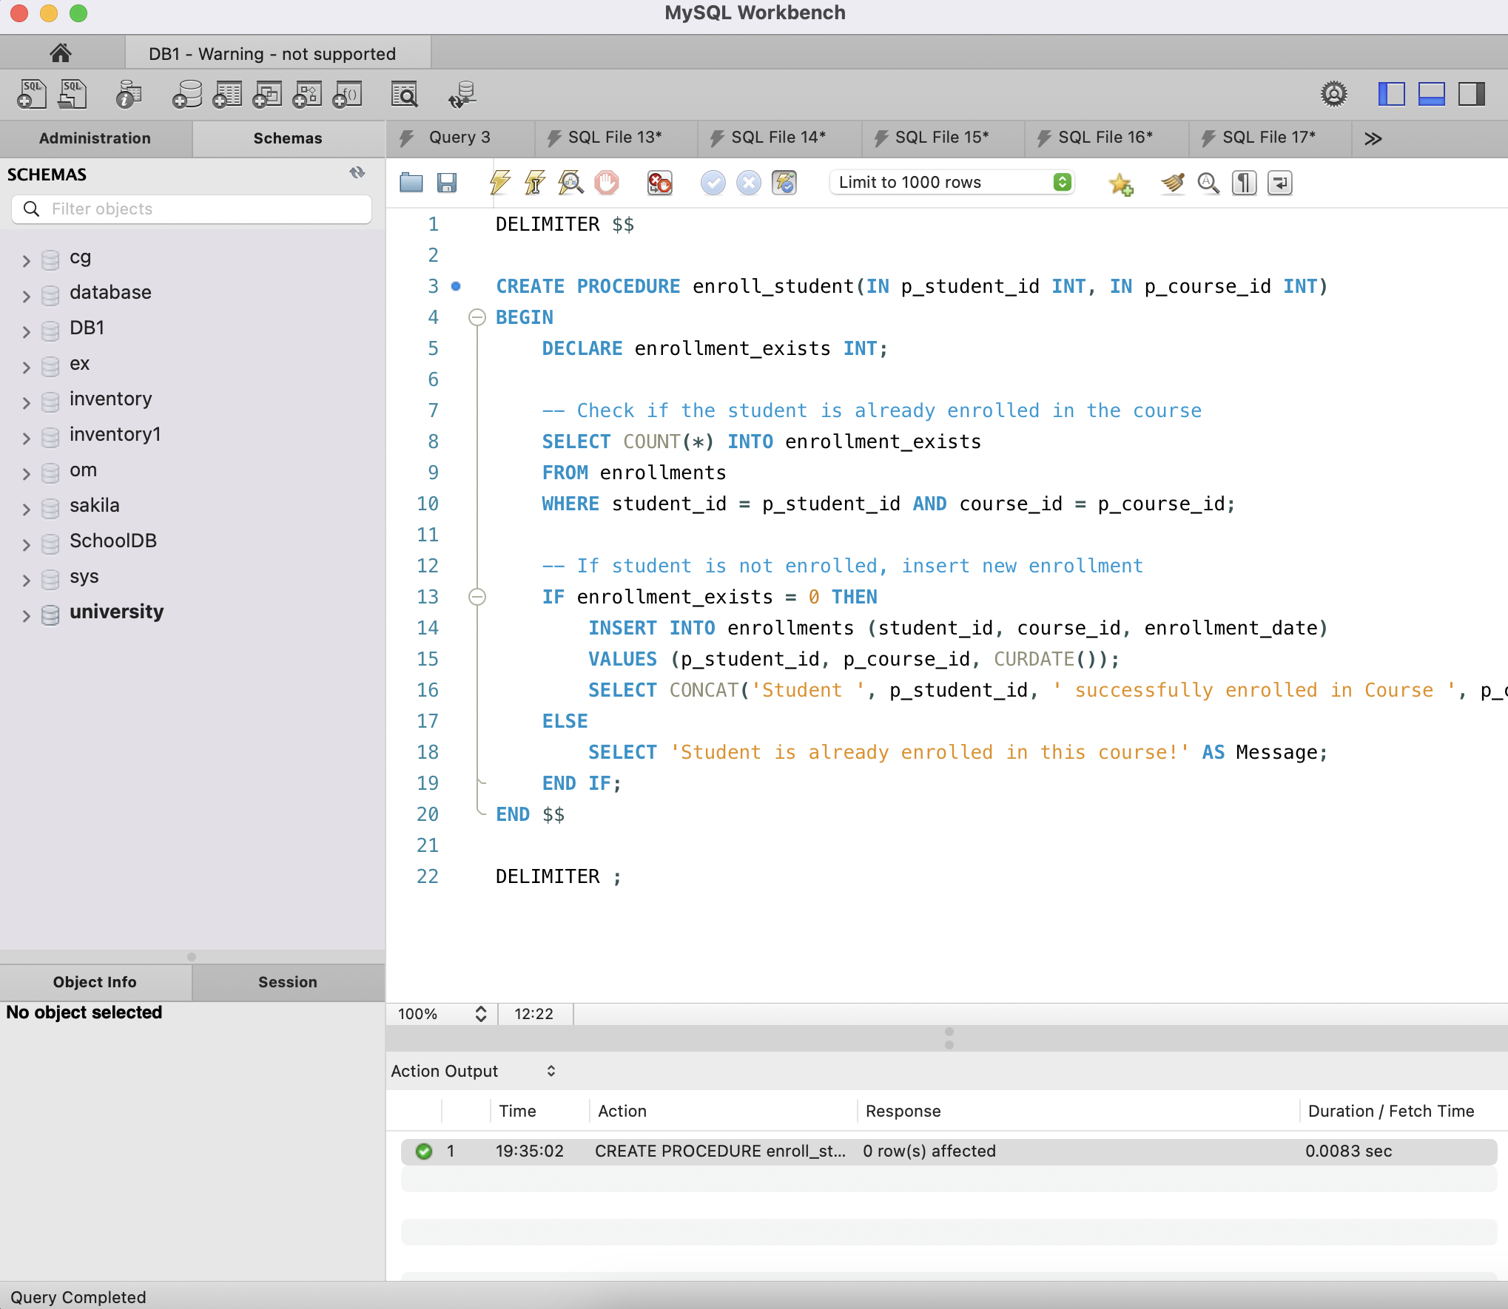

How it works:

• Verifies whether the student is already enrolled in the course.

• If not enrolled, adds a new record to the enrollments table.

• Returns a success message or an error message if the student is already registered.

Testing the Stored Procedure

